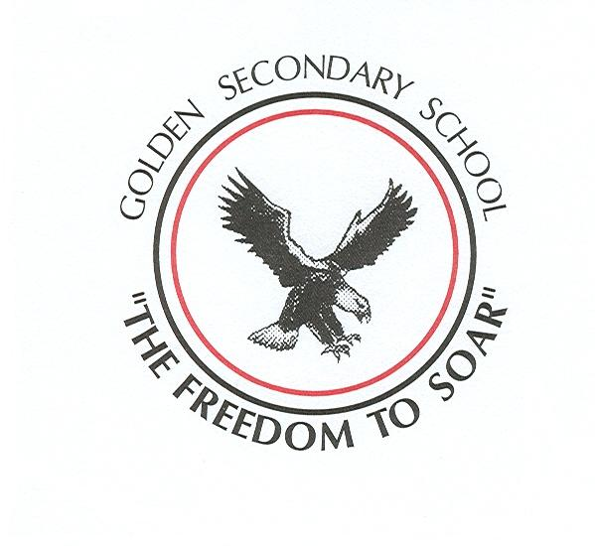
Golden Secondary School
1500 9th Street South, PO Box 1350
Golden, BC V0A 1H0 250-344-2201

June 2023

Dear 2023 Grad and Grad Parent:

The “Big Day” is approaching quickly; the following letter is to give the grads and parents some information as to what will be taking place on Wednesday, June 28, 2023, GRAD CEREMONY and Thursday, June 29, 2023, GRADUATION PROM.

Wednesday, June 28, 2023

10:00 am Grad Rehearsal at the arena. ALL GRADS NEED TO ATTEND (done by 12:00)
- After the rehearsal Grads will set up chairs

11:00 am ALL GRADS need to collect CAP and GOWNS from GSS
- Make sure you bring them both back for the ceremony that night

GRAD CEREMONY at the Golden Arena

5:15 pm – GRADS arrive and go upstairs at the Arena to the ARENA LOUNGE
- Please show up in your cap and gown

5:25 pm Doors open to public
- first four rows PARENTS ONLY
- reserved section at the side for bursary presenters & staff – There will be signs

6:00 pm Grad Ceremony Commences

8:00 pm Grads Return Grad Gown upstairs at the Arena: after the ceremony is completed and pictures have been taken, Grads MUST return their gown before 8:30 pm

Thursday, June 29, 2023

GOLDEN SECONDARY SCHOOL
4:00 pm – LAST LAP + Pictures

EAGLES EYE FOR PROM
6:00 pm – Upload from the base of the Gondola
- A list with your name, and your dates name will be provided at the base for Ms. Doolaar and Mr. Archibald
6:45 pm – Pictures and Appies
- Pictures with Jena Mathews
7:30 pm - Dinner for Grads & Guests only – dancing, games, time together

10:30 pm – Gondola download

A couple of important points;
- Graduation Ceremony: the first 4 rows are reserved for parents only, and the rows behind the parents are reserved for families.

- Grad Gowns: Grads must arrive at the arena at 10:00 am for rehearsal, and GOWNS will be distributed AFTER at GSS. After the ceremony and pictures are taken, the grad must return the gown to the arena lounge before 8:30 pm the same night.

- Grad Students’ Numbers will be displayed on the office window if the student is in good standing (ex., paid grad fees, no outstanding textbooks, etc.). Grad Students will not be confirmed for the ceremony or prom until they are in good standing. If their number is not on the list, they need to check with one of the administrative assistants to find out what needs to be done.

If you have questions, please contact Mr. Archibald at Golden Secondary at 250-344-2201 or by email.

Your Grad 2023 sponsors:

Mrs. Petrovics (Jennifer.petrovics@sd6.bc.ca)
Ms.Hagardt (Brianne.Hagardt@sd6.bc.ca)
Ms. Craigie (Amanda.Craigie@sd6.bc.ca)

