Mom’s Pantry fundraising
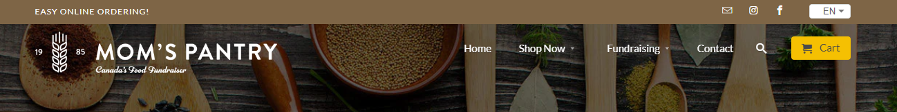
Grad of 2023 would like to invite you to join our FIRST FUNDRAISER of the year. Starting TODAY and running until October 24, 2022.
- Click on the link - https://momspantry.ca/
- Go to “shop now”
- Add to your cart
- Click on GROUP PICKUP
- SELLER – is the name of the GRAD you would like to sponsor – Be sure to spell their name correctly!
- Order Number: 358332 Group Passcode: 32268
- Checkout and Pay ONLINE – a receipt will be sent to the email address you added
- We will notify you when we expect delivery

